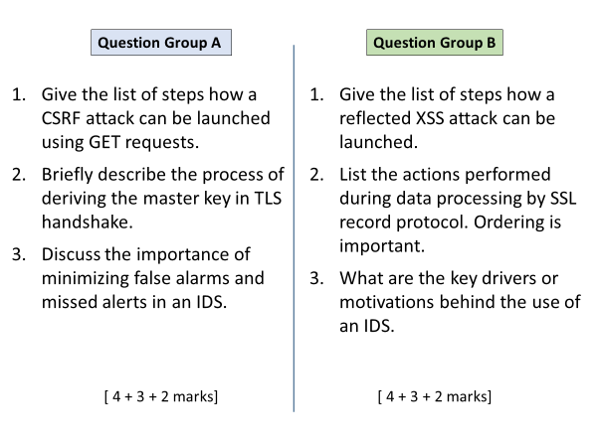
A
1
User logs in to vulnerable website.
User receives a link for attacker’s site.
User visits attacker’s site that contains an <img> element with source with s malicious URL. OR attacker site contains a link <a> whose target is malicious URL.
Clicking the link (or browser trying to download image) causes CSRF request to be sent to vulnerable site along with session cookie.
2
Client and server exchange hello messages sharing each other’s random number.
Both securely exchange or establish pre-master key S.
Master key is derived using a function that takes S and both randoms as input.
3
False alerts means wasted time in looking into the event details, ultimately users will start ignoring alarms.
Missing alerts means a false sense of security, attacks slipping through.

B
1
User logs in to vulnerable website.
Attacker sends user a malicious link, containing a <script>.
User clicks the link, request containing malicious <script> goes to vulnerable site.
Vulnerable site returns a response, which also reflects back the user’s script input.
Attacker’s script runs in user’s browser.
2
In order:
Fragmentation, compression, mac calculation, padding, encryption, adding header
3
The quicker the attack can be caught and blocked, the lesser the damage will be done. That’s why IDS aims to provide real time monitoring.

